Project 15: Light Tracking Smart Car

1. Description
Do you find that the street lights outside will light up when it gets dark and goes off at dawn? Next, we will learn the main component that causes this circumstance, which is "photoresistor".
Working Principle: It is a resistor made by the photoelectric effect of a semiconductor, which is very sensitive to ambient light, thus its resistance value will vary with different light intensity.
We seek to use this feature to design a circuit and generate a photoresistor module. The signal end of the module is connected to the analog port of the microcontroller.
When the light intensity increases, the resistance decreases, and the voltage of the analog port rises, that is, the analog value of the microcontroller goes up. Otherwise, when the light intensity decreases, the resistance increases, and the voltage of the analog port declines, that is, the analog value of the microcontroller becomes smaller. Therefore, we can use the photoresistor to read the corresponding analog value and sense the light intensity in the environment.
It is commonly applied to light measurement, control and conversion, light control circuit as well.
In this project, we will use the left and right photoresistors to control the car to find the light source.

2. Preparation
（1）Insert the micro: bit correctly into the expansion board
（2）Connect the battery holder to the expansion board
（3）Turn on the power switch（Slide the POWER switch to ON end）
（4）Connect the micro：bit and computer via a micro USB cable
（5）Open the Web version of Makecode
If you want to add the Mini car extension library(you can refer to the "1. Development environment configuration "file).

3. Circuit Diagram

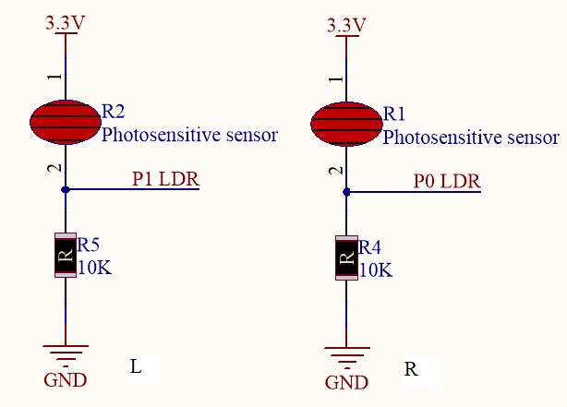

4. Read the Photoresistor
You can upload the code “code_1.py” directly from the tutorial (read the "Development Environment Configuration" file if in doubt).
Code 1：
from microbit import *

while True:
LDR_L = pin1.read_analog() #Read the analog of P1and set it to LDR_L
LDR_R = pin0.read_analog()
print("LDR_L:", LDR_L) #Print the value of LDR_L
print("LDR_R:", LDR_R)
sleep(1000)
Test Result: Download code 1 onto micro:bit board, don’t plug off USB cable. Click“REPL”and press the reset button, then the BBC microbit REPL window displays the ambient light intensity detected by the photoresistor on the expansion board. As the external light intensity and gradually decreases, the analog value gradually decreases. On the contrary, the analog value is gradually increasing.
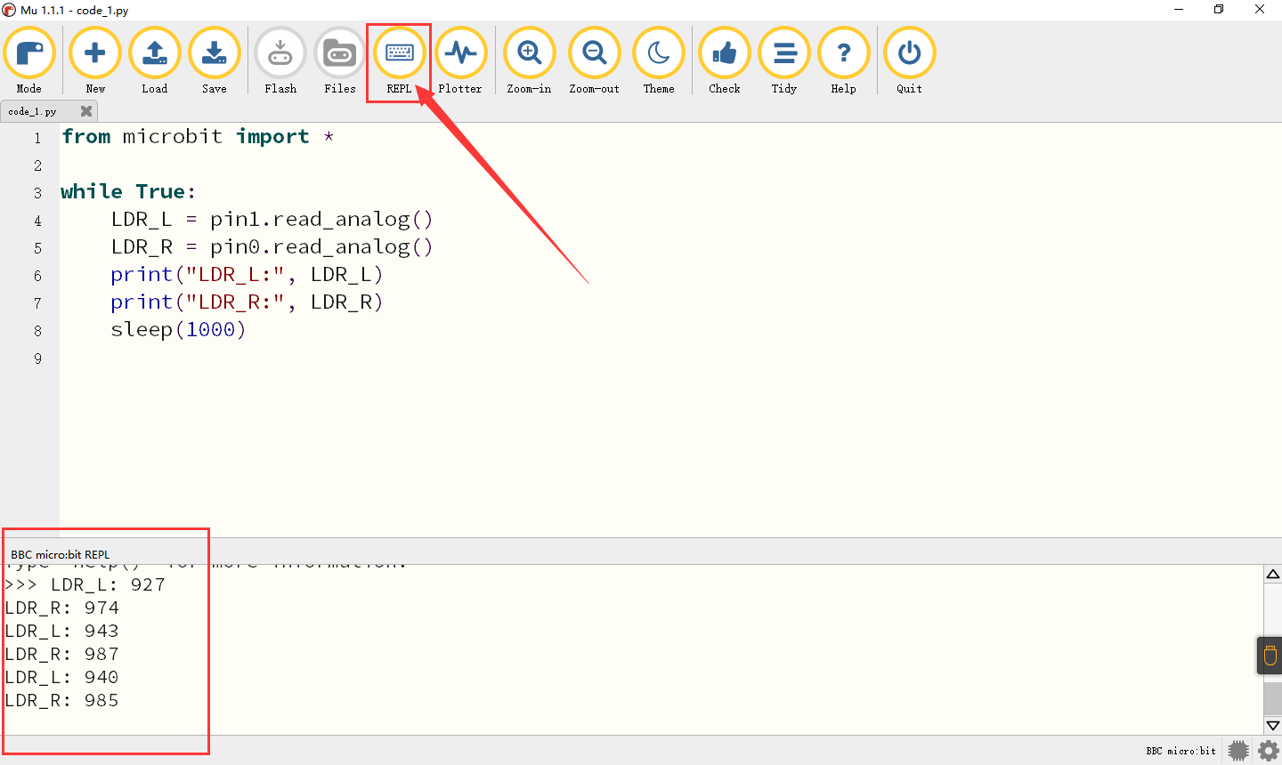

6. Flow Chart

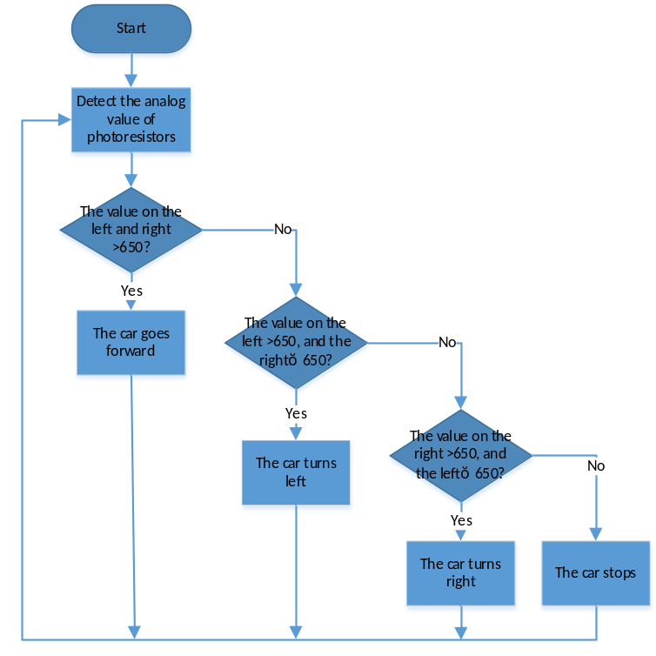

7. Light Tracking Smart Car
You can upload the code “code_2.py” directly from the tutorial (read the "Development Environment Configuration" file if in doubt).
from microbit import *
from keyes_MiniCar import * #Load the library file of keyes_MiniCar
minicar = MiniCar() #Instantiate an object MiniCar()as minicar

while True:
LDR_L = pin1.read_analog() #Read the value of the photoresistor
LDR_R = pin0.read_analog()
if LDR_L > 650 and LDR_R > 650: #Judge if brightness of both sides＞650
minicar.Motor_L(1, 70) #It is a code of advance
minicar.Motor_R(1, 70)
elif LDR_L > 650 and LDR_R <= 650: #Judge if the left brightness＞650，right≤650
minicar.Motor_L(0, 70) #Left turn code
minicar.Motor_R(1, 70)
elif LDR_L <= 650 and LDR_R > 650: #Judge if the left side of the car≤650，right＞650
minicar.Motor_L(1, 70) #The car turns right
minicar.Motor_R(0, 70)
else:
minicar.Motor_stop() #The car stops

7. Test Result
After uploading the code, turn on the switch on the rear of the car, then you can use the flashlight to play with the car. It’s best used in a relatively dark environment. When the ambient light intensity is above 650, the car will keep moving.

